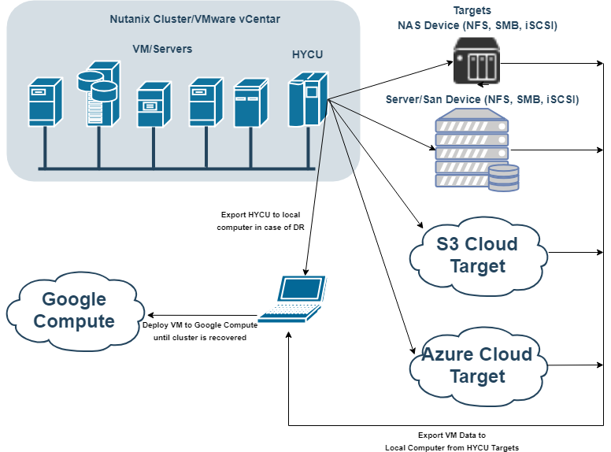
DR Recovery Scenario for Google cloud
Prerequisites:
- Working Windows Physical Machine
- vmPlayer available for download on https://www.vmware.com/products/workstation-player/workstation-player-evaluation.html
- Installed and configured QEMU package for converting Virtual HDD files, Download QEMU From https://www.qemu.org/
- Backup of HYCU controller (exported Virtual HDD files)
NOTE: use CTRL+ left mouse click on video links to open video
IMPORTANT: Watch for uppercase and lowercase letters in command

PREREQUISITE STEP 1 (Get and Install QEMU) video file
- Get QEMU from https://www.qemu.org/
- Install QEMU to local computer (run installer, select all and just go next until finish)
- Add QEMU Install folder to Environment Variables in sections path
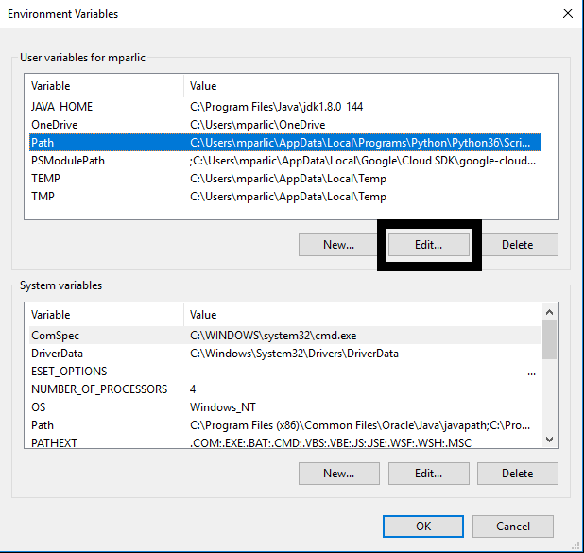
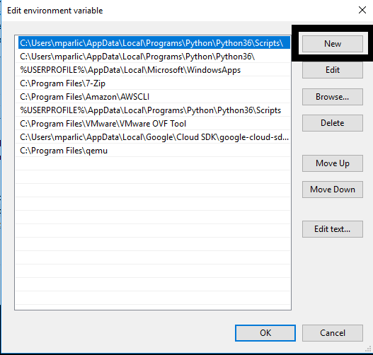
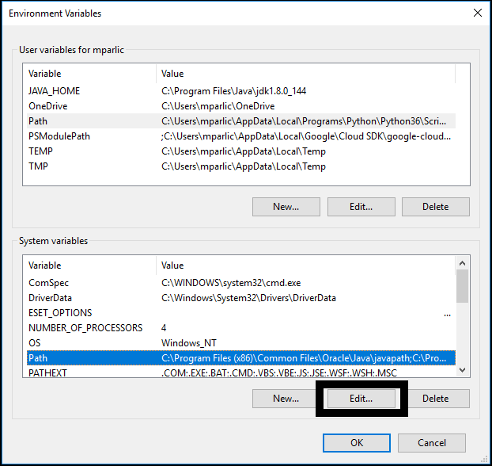
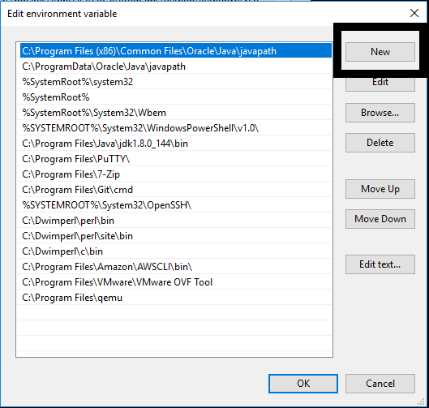

PREREQUISITE STEP 2 (Get VM Disk files of old HYCU Controller) video file
- Go to target where you have backup of HYCU controller
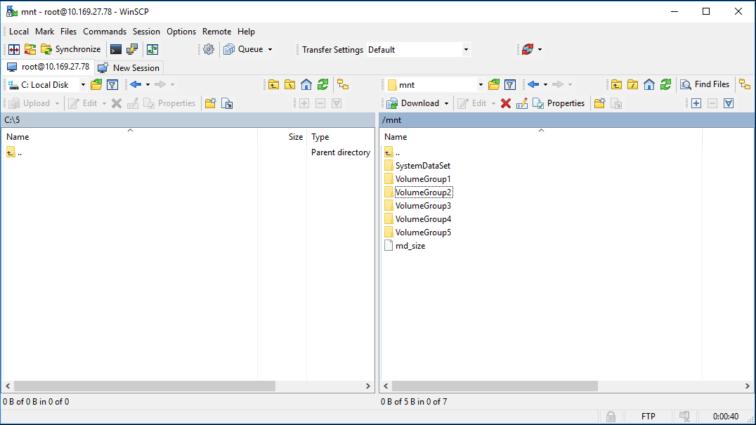
- Navigate to bkpctl directory
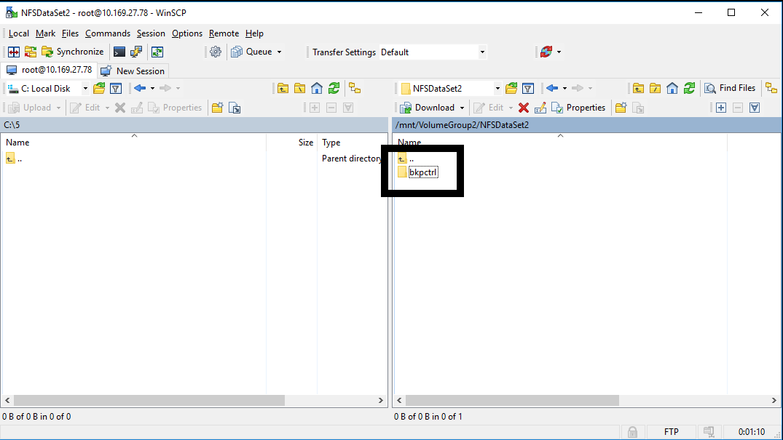
- Enter to directory that have name of UUID of previous HYCU controller
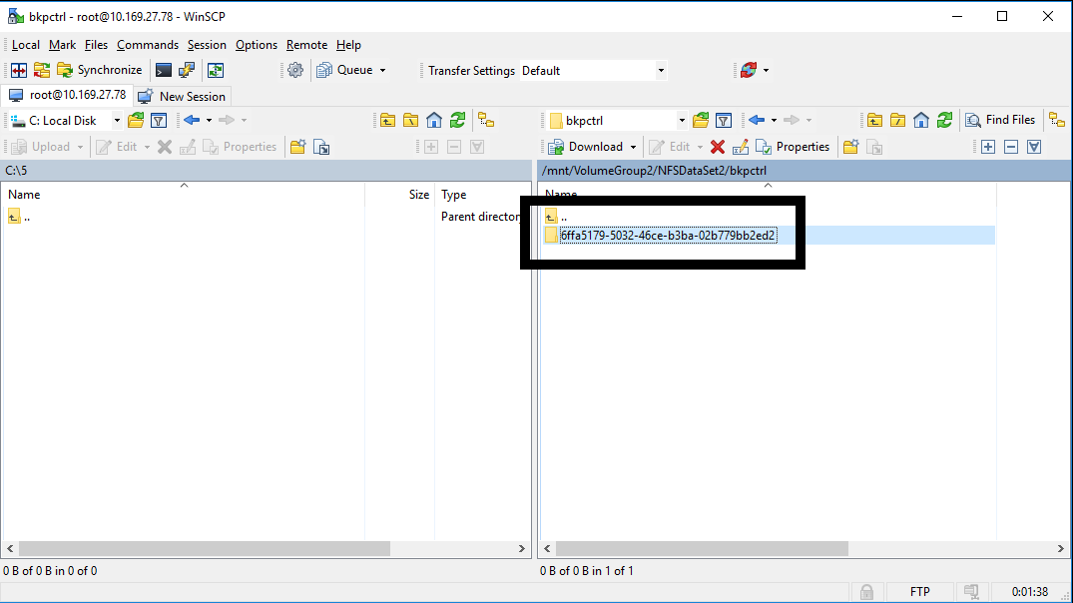

- Navigate to internal_backup_<source UUID>
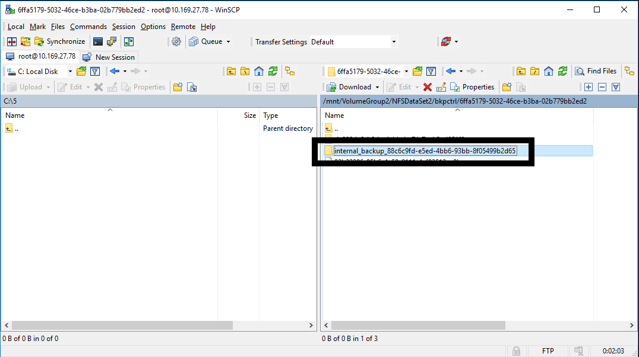
- Copy raw disk image files of HYCU controller to local computer (Virtual HDD files has crm files with same name, you only need files without extension
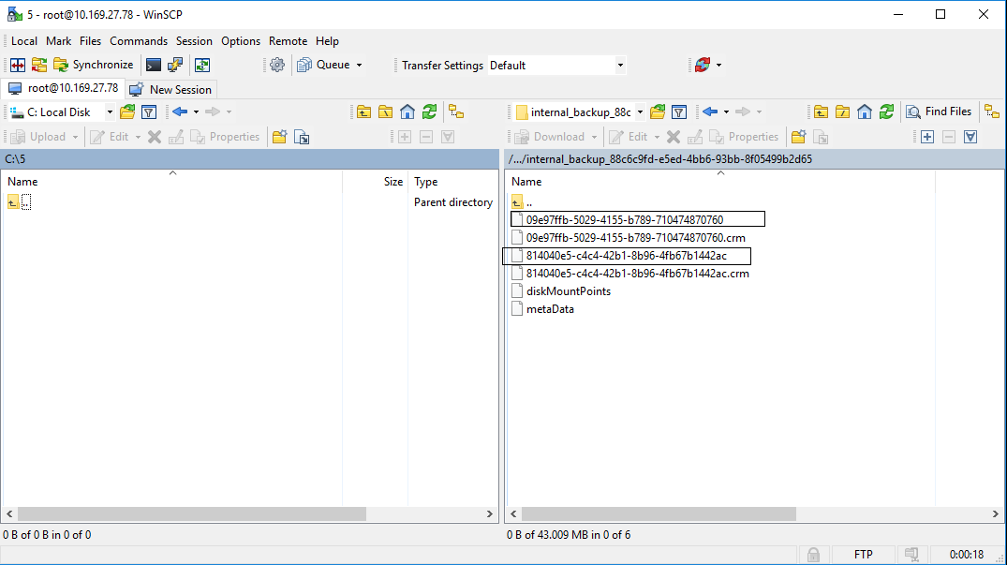
- Convert raw files to VMDK with QEMU tool (smaller file is boot disk, and should be first disk of VM)
command that need to be used is qemu-img convert –f raw –O vmdk <name of raw image file> <name of vmdk>.vmdk
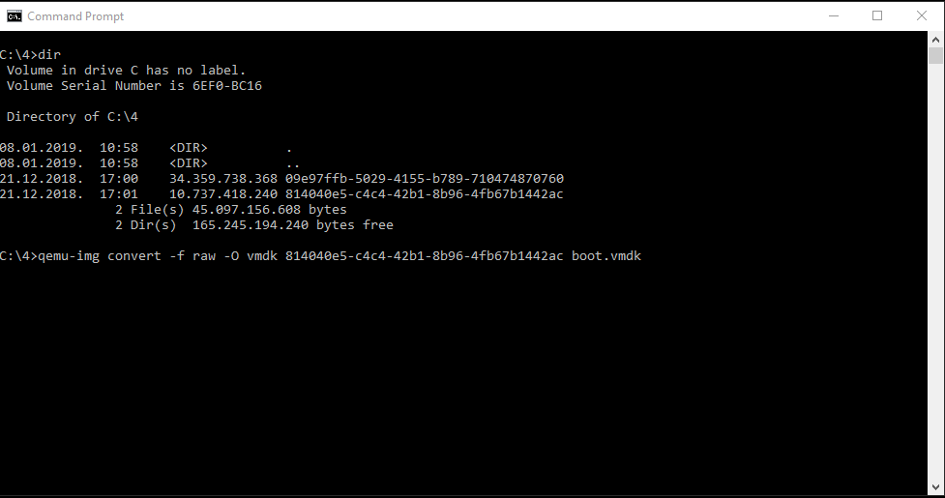
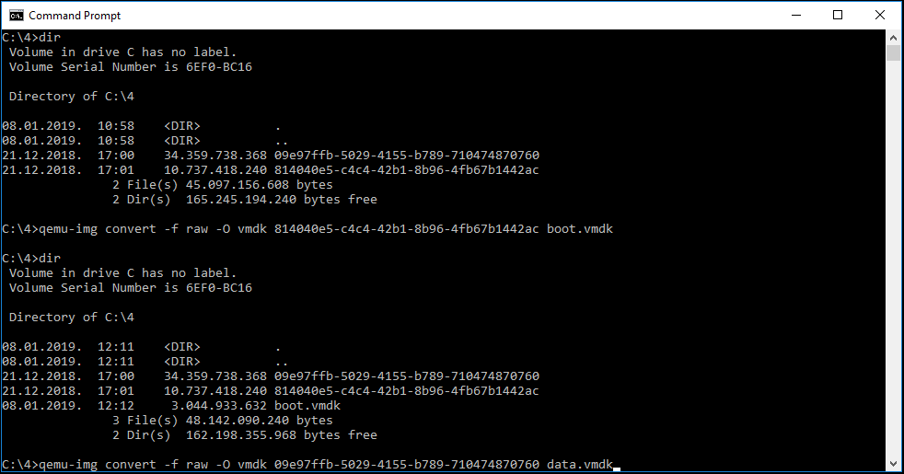
STEP 1 (Create new VM in VM Player and customize it) video file
- Select Create New Virtual Machine
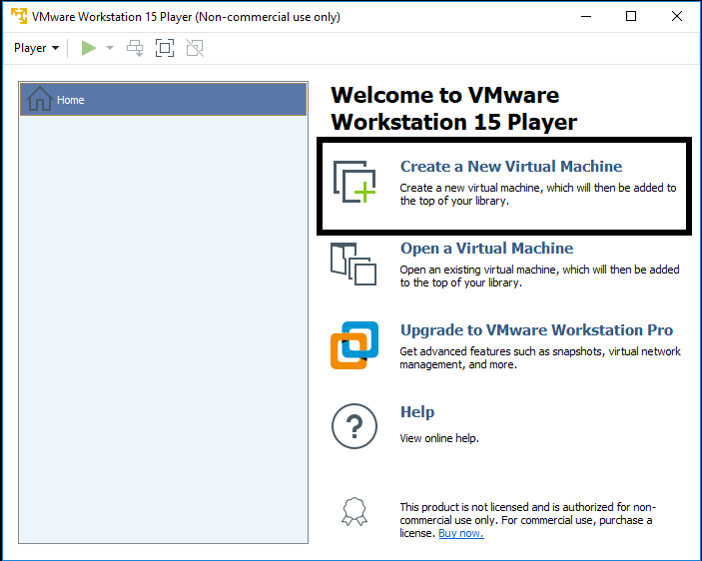
- On next screen select I will install operating system later
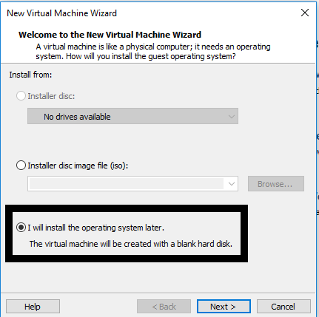

- On next screen select Linux on top and Version CentOS 7 64-bit
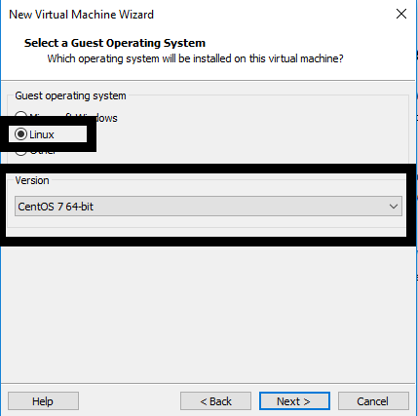
- Enter VM name and select location on local computer where VM will be stored
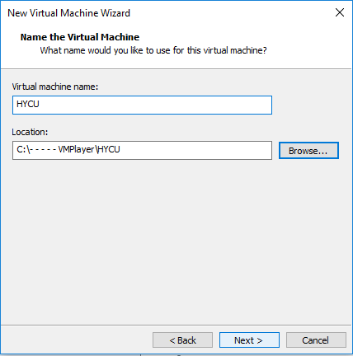

- Enter size of VM boot disk to be 10 GB and select Store Virtual disk as single file
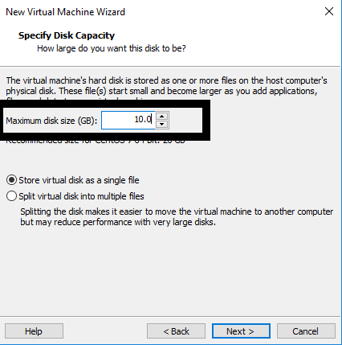
- On next screen click on finish
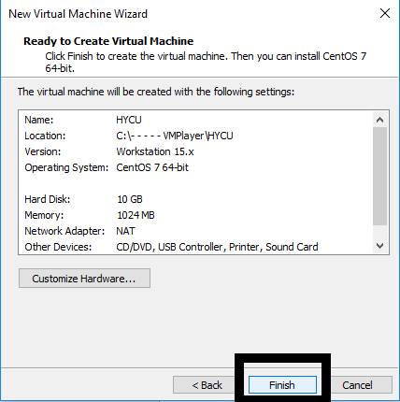

- Copy converted files to folder where your new VM is created
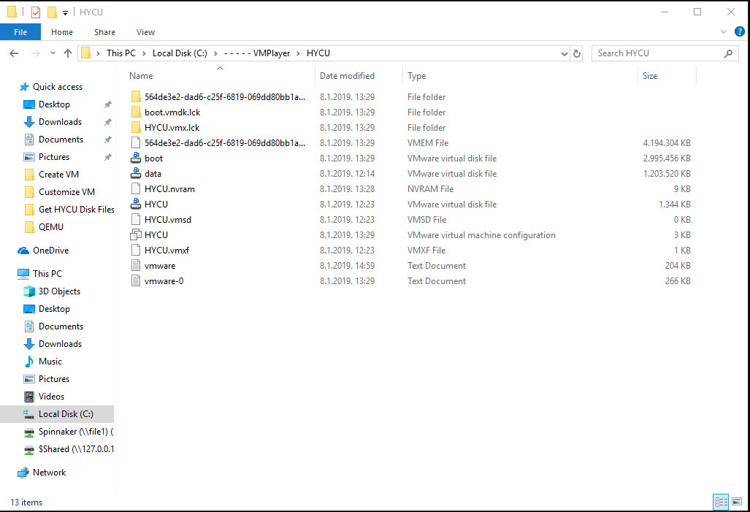
- Edit .vmx file with text editor .vmx file is located in folder where you created new VM (change line scsi0:0.fileName = "HYCU.vmdk" to scsi0:0.fileName = "boot.vmdk")
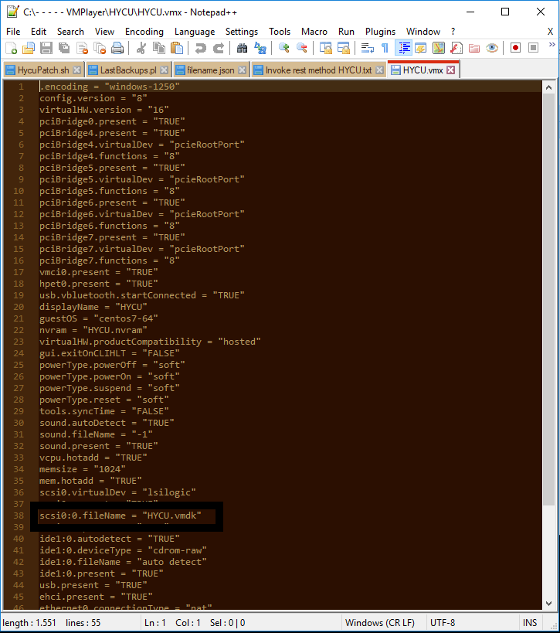

- Save File
- Open VM player, select VM and Select Edit virtual machine settings
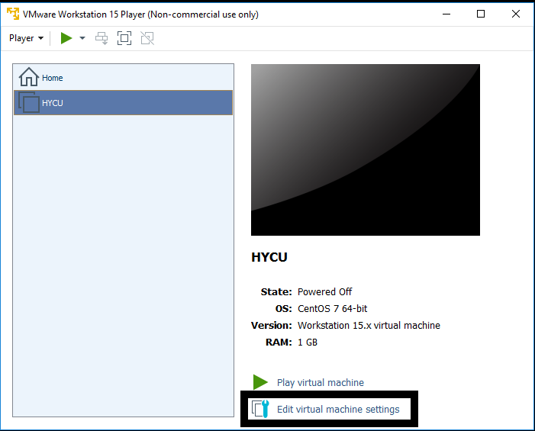
- Edit memory settings to 4 gb
- Edit Processors to 2 cores
- Remove CD drive
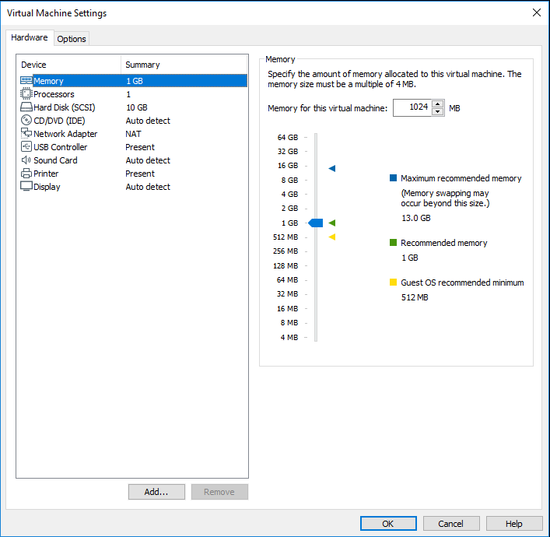

- Add another HDD, select SCSI hdd drive select use existing virtual disk, browse for data hdd file, click on finish and click on keep existing format
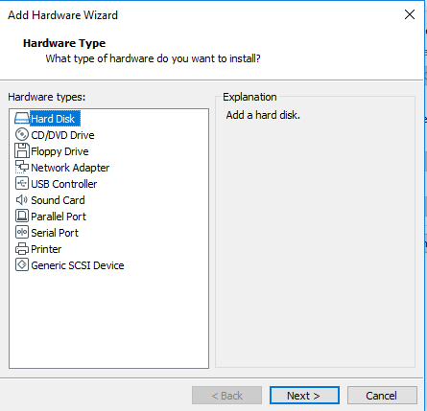
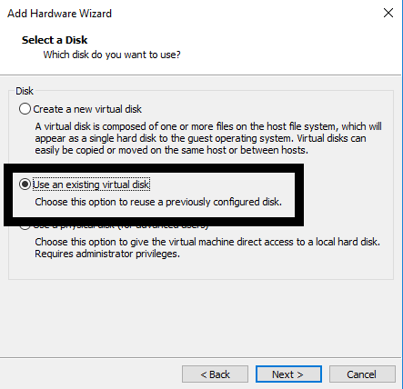
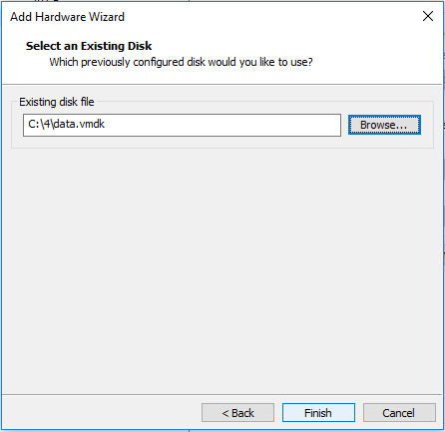
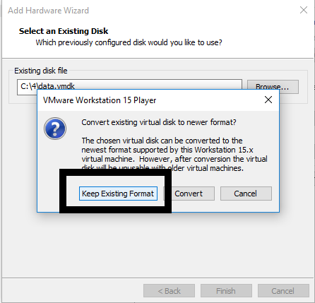
- On network controller select Nat
- Save VM settings
- Run VM
- When controller is up, login with credentials hycu / hucu/4u use command sudo nmtui to access network settings of controller, you will be asked to enter password one more time so enter hycu/4u
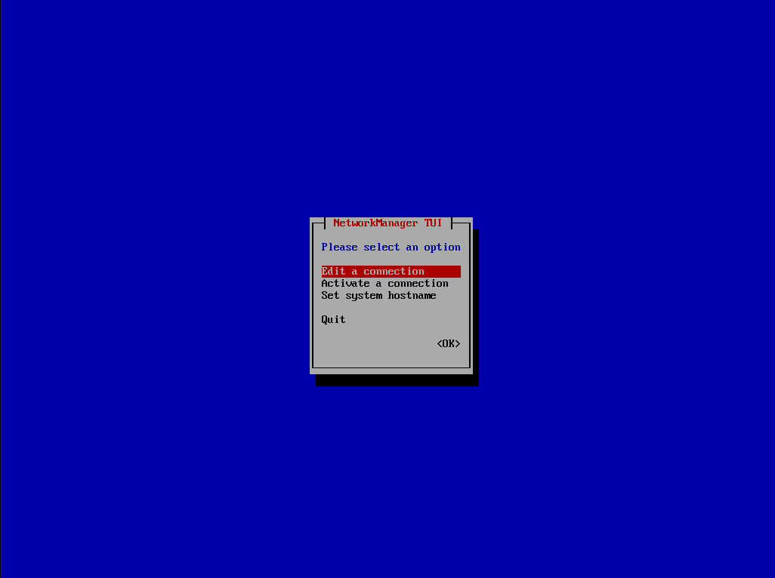
- Select Edit a connection
- Select Wired connection 1 and delete it
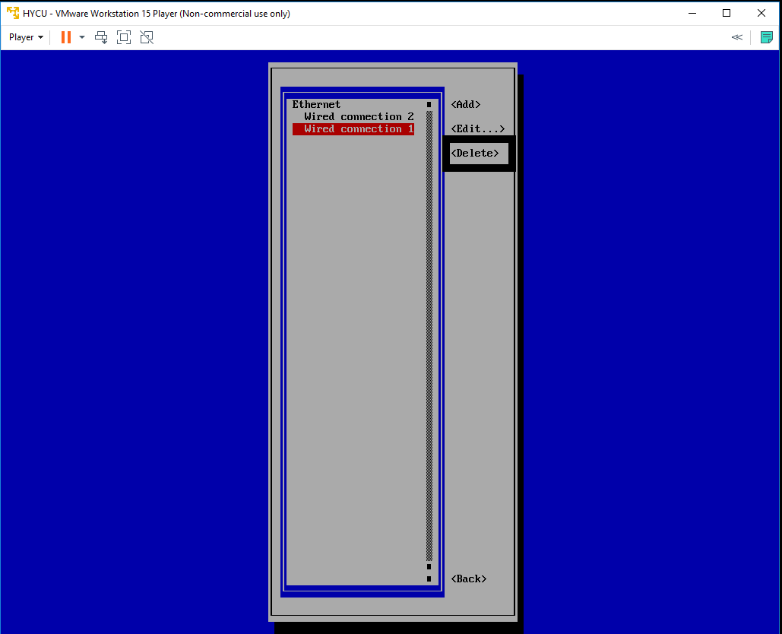

- Select Wired connection 2 and Edit it, change name to Wired connection 1
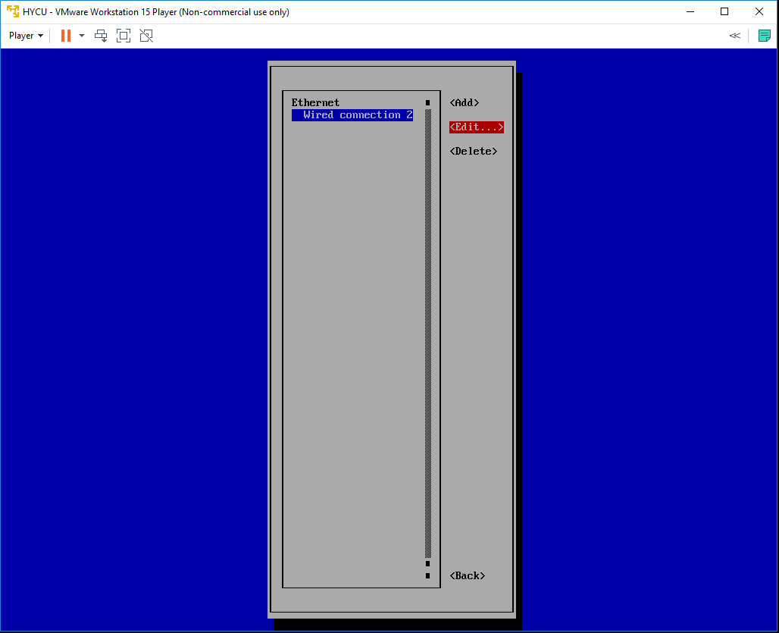
- Quit nmtui and reboot controller sudo shutdown –r now
- Login to console with same credentials and run ifconfig command to get controllers IP address
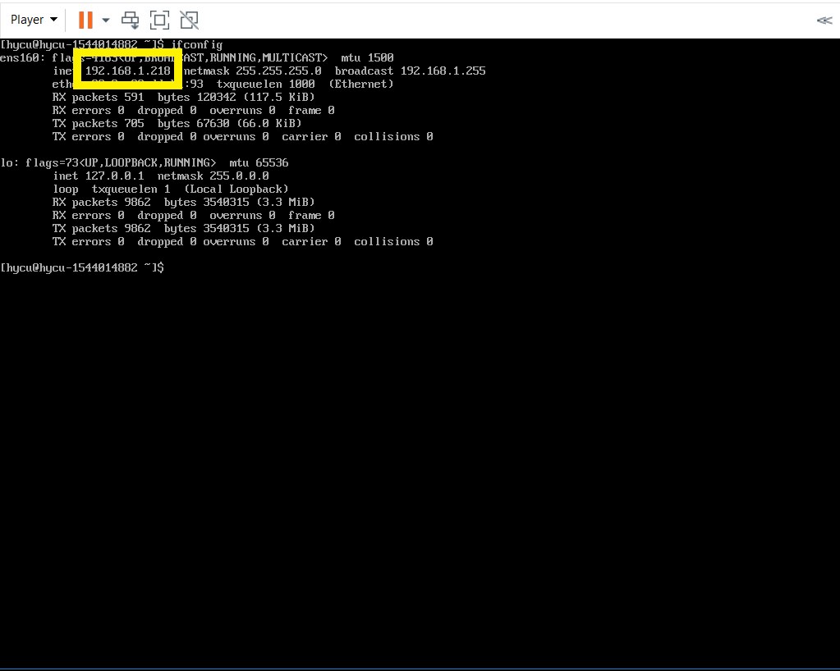
- Use that address to access HYCU GUI
STEP 2 (Restore VM Virtual Disk Files and convert them if needed) video file
- Navigate to Virtual Machines tab on left
- VMs that have backup will be shown as PROTECTED_DELETED since source is not available
- Select VM and select Restore VM or vDisks
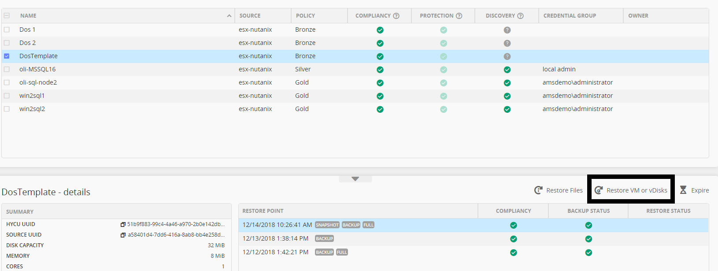

- New form will be shown. Disregard warning.
- Select Export vDisks
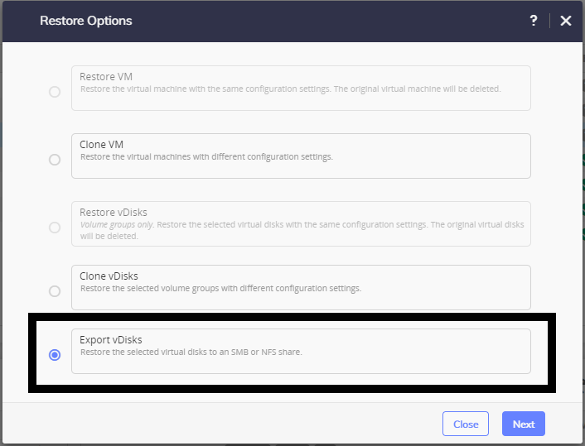
- Select vDisk that you want to export
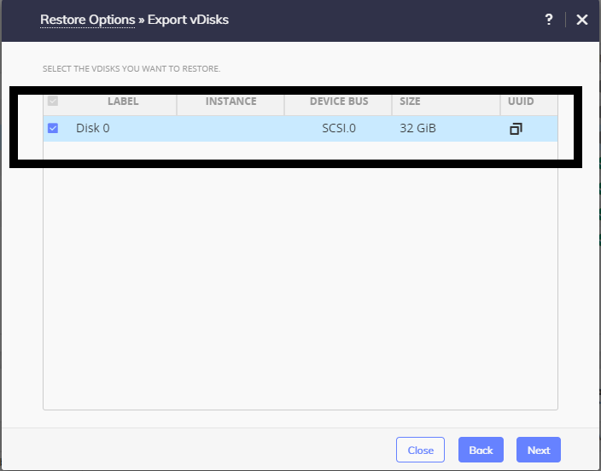
- Enter Share Data
For SMB
- Domain, Username and Password are optional if exists
- Enter SMB server DNS name or IP address
- Enter Shared Folder name in format /<FolderName>
- Choose Restore Instance (recommended is AUTOMATIC)
For NFS
- Enter NFS server DNS name or IP address
- Enter Shared Folder name in format /<FolderName>
- Choose Restore Instance (recommended is AUTOMATIC)
- Select Restore
- When restore job is completed, you should have something like this in shared folders. If you have multiply disk exported you will have multiply *.vmdk files in folder
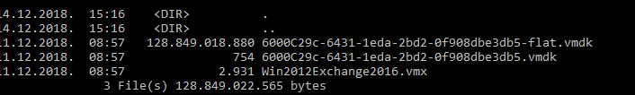
STEP 3 (Download and install Google Cloud SDK) video file
- Download Google Cloud SDK from address https://cloud.google.com/compute/docs/gcloud-compute/
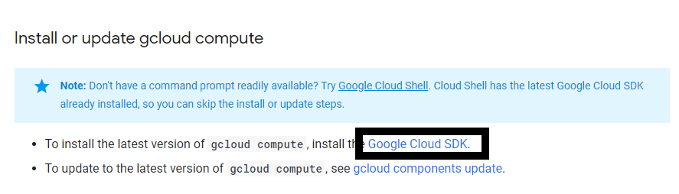
- Follow instructions from same page
- Login to Google cloud dashboard and navigate to storage
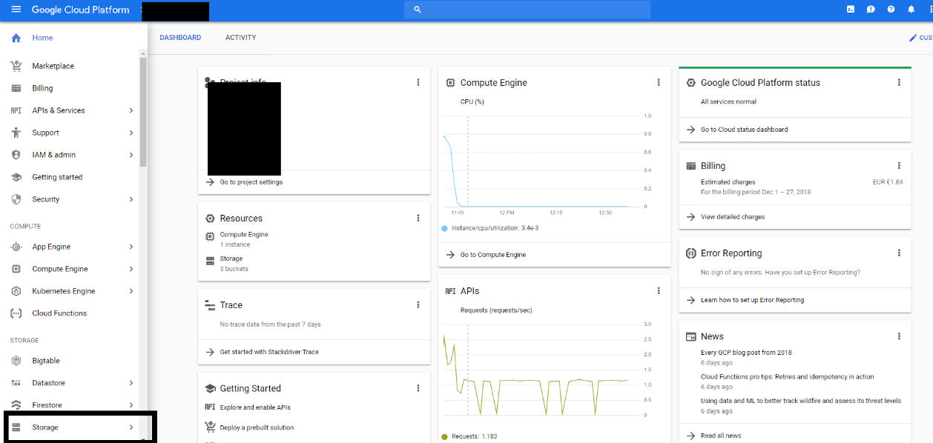
STEP 4 (Create bucket and upload VM Files) video file
- Create new bucket
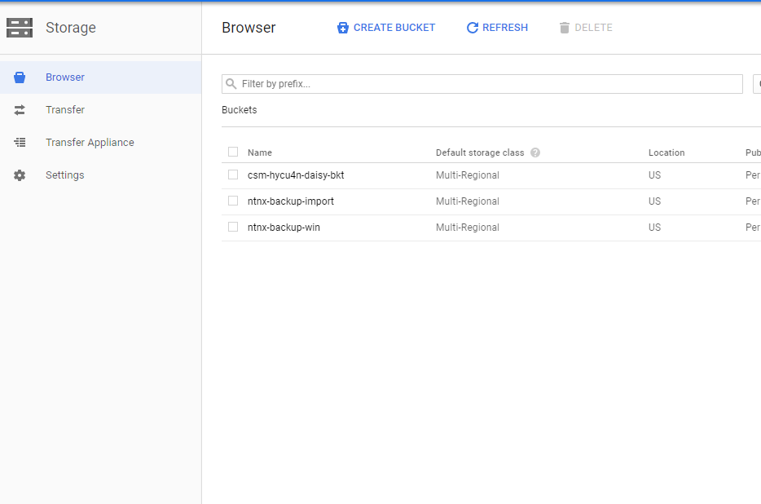
- Upload VM disk files to bucket

STEP 5 (Import VM disk to custom images) video file

- Open Google Cloud SDK Shell
- Use https://cloud.google.com/compute/docs/images/importing-virtual-disks for additional info about importing
- Enter command gcloud compute images import hycu --source-file gs://<name of bucket>t/<name of virtual hdd file>.vmdk --os name of operating system
- Confirm with Y when you are asked to add permissions
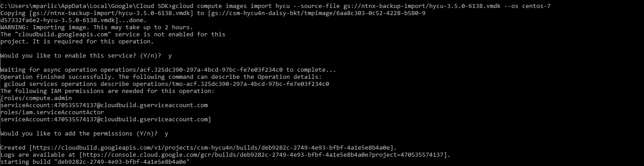
- When you see message like this import job is finished

STEP 6 (Deploy VM from custom image) video file
- Go back to your Google Cloud Web Console and select Compute Engine
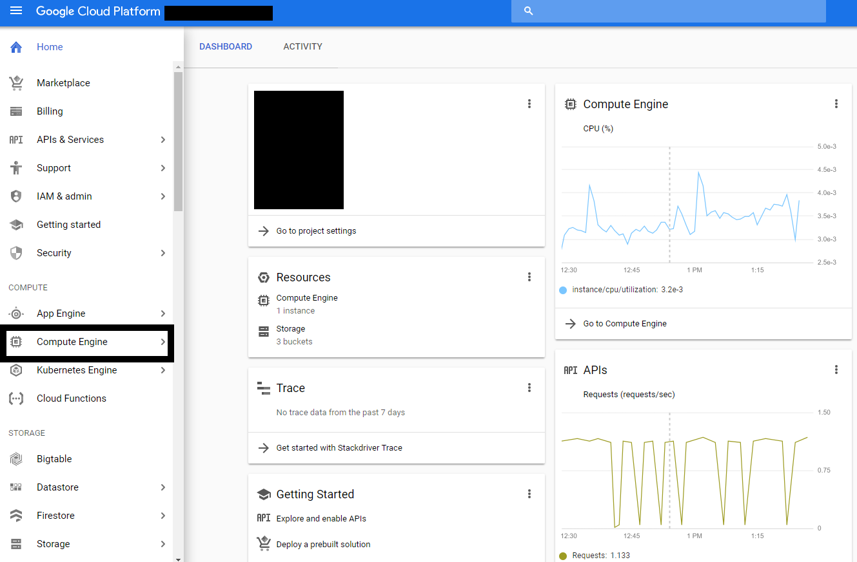

- Select Create Instance
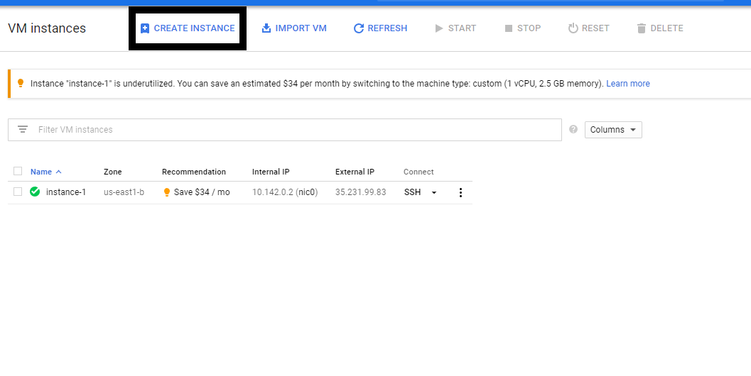
- Enter Instance name, set CPU and Memory config, and change boot disk
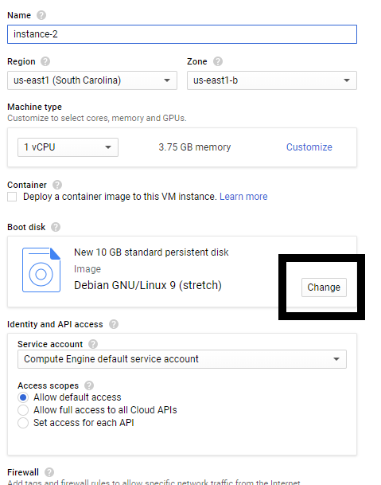
- Select Custom Images
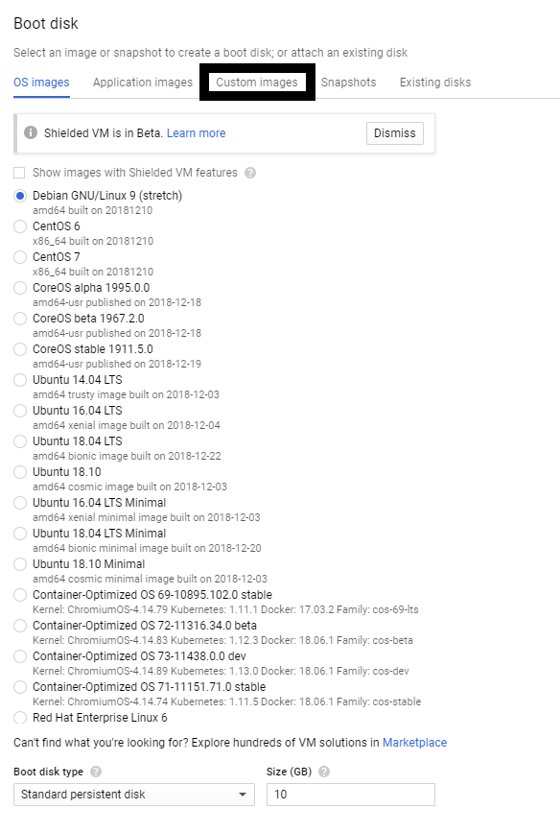

- From list select image that you are imported
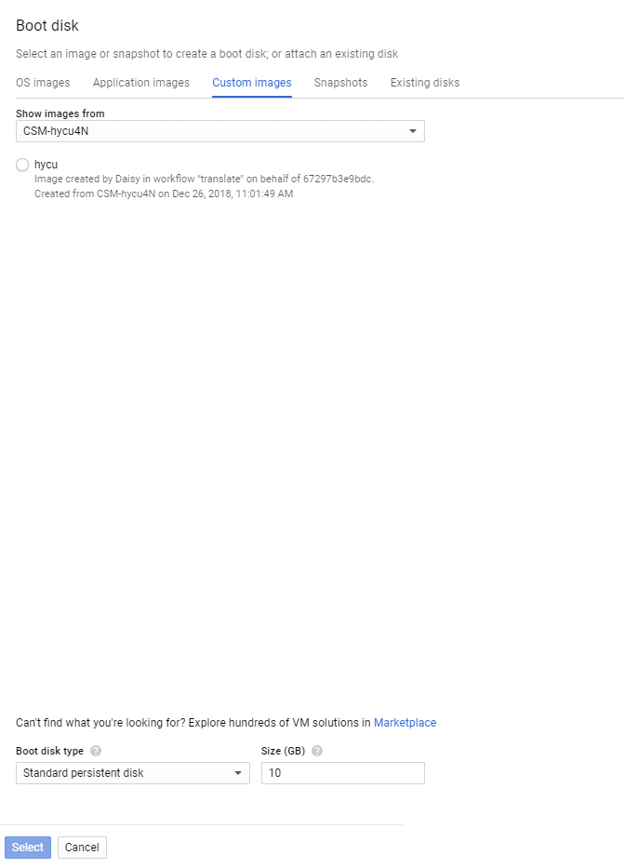

- Press Select
- Press Create
- When deploy of vm is done you can Power it on
- On VM instance page you will have Internal IP and externa IP for deployed VM

